
ST PATRICK’S SECONDARY SCHOOL
2026 MALAWI SCHOOL CERTIFICATE OF EDUCATION MOCK I EXAMINATION
PHYSICS
PAPER I
(100 Marks)

Subject number: M164/I
FRIDAY 22, March 2026 Time Allowed: 2 hours
8:00 am – 10:00 am
INSTRUCTIONS:
Question Number | Tick if Answered | Do not write in this column
1
2
3
4
5
6
7
8

9
10
11
12
13

- Write your official name and class on top of every page.
- The paper contains two sections; A and B, on 12 printed pages. Please check.
- In section A, there are 10 short answer questions. While in section B, there are three descriptive questions.
- Answer all the questions in the spaces provided.
- Maximum number of marks for each answer is indicated against each question.
- Use of electronic calculators is allowed.
- In the table provided on this page, tick against the number of the question you have answered.
h). Hand in your paper to invigilator when time is called to stop writing.

© 2026 SPSS
SECTION A (70 marks)
- a. Figure 1 shows a measuring instrument.

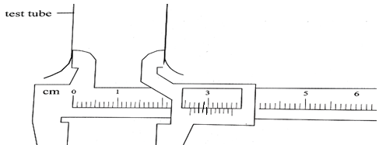

- Name the instrument?
________________________________________________________(1 mark)
- Work out the internal diameter of the test tube.

(3 marks)
b) Using electricity, explain how an unmagnetised steel bar could be turned into a magnet. ________________________________________________________________________________________________________________________________________________________________________________________(3 marks)
- a) Mention any one difference between Kelvin and Fahrenheit temperature
scale.
_________________________________________________________________________________________________________________________(1 mark)
b) Convert 310 K to degrees fahrenheit (ºF)

(3 marks)
c) State one reason why platinum wire is used in a resistance thermometer
___________________________________________________________(1 mark)
d) Define the term elastic limit
___________________________________________________________(1 mark)
e) State any one applications of Hooke’s law. __________________________________________________________ (1 mark)

- a) Give any one factor which affects pressure exerted by a solid.
________________________________________________________________
(1 mark)
b) A rectangular block of metal with dimensions 20 cm × 5 cm × 3 cm has a mass of 900 g. What is the greatest pressure it can exert when placed on the bench?

(3 marks)
c) i. State the SI unit of moment of a force. ________________________________________________________(1 marks)
ii. Figure 3 shows two weights on two sides of a pivot.
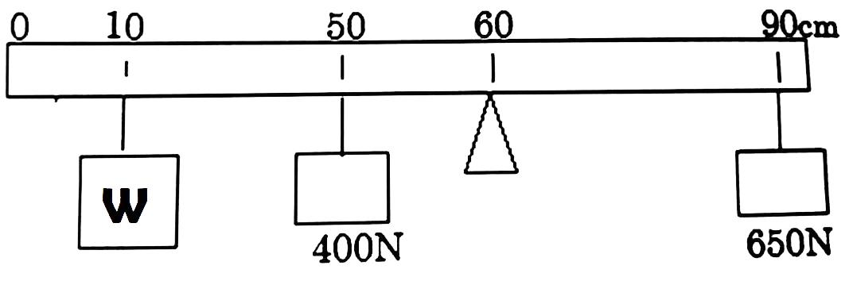
Work out the value of W

(3 marks)
d) Give one use of a capacitor.
_________________________________________________________(1 mark)
- a) State any one condition that must be satisfied for volume of any gas to be inversely proportional to pressure.
_________________________________________________________(1 mark)
b) Explain why pressure of a gas increases as volume of the gas decreases.
_______________________________________________________________________________________________________________________(2 marks)
c) Figure 1 below shows a cylindrical block of wood of length L floating in water of density 1g/cm³.
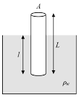
Figure 1
- If the weight of displaced water is 2.8N.Find volume of wooden cylinder submerged in water.

(3 marks)
- State any two forces acting on the cylindrical object.
____________________________________________________________________________________________________________(2 marks)
- Calculate length l of wooden cylinder imersed in water of diplaced water if area, A is 7 cm².

(2 marks)
- a) State the law of conservation of mechanical energy.
_______________________________________________________________
(1 mark)
b) A car starts from rest and accelerates at 3 m/s² in 10 seconds and then moves with constant velocity for 5 seconds before coming to rest in 15 seconds.
- Sketch a velocity – time graph to show the motion of a car.

(2 marks)
- Calculate the retardation of the car as it comes to rest.

(2 marks)
- How far does the car travel?

(3 marks)
c) Explain why water waves bend as they move from shallow waters to deep waters. ________________________________________________________________________________________________________________________________________________________________________________________________
(2 marks)
d) Why does sound travel faster in solids than in gases? ________________________________________________________________________________________________________________________________
(1 marks)
- a) Give any two differences between a real image and a virtual image.
________________________________________________________________________________________________________________________________
(2 marks)
b) An object 2 cm high is placed 15 cm away from a convex lens of focal length 10 cm. Using the lens formula, calculate the image distance.

(3 marks)
c) Describe how the speed of sound in air could be determined using an echo. ________________________________________________________________________________________________________________________________________________________________________________________________________________________________________________________________________________________________________________________________
(3 marks)

d) Figure 2 shows two trolleys before and after collision.
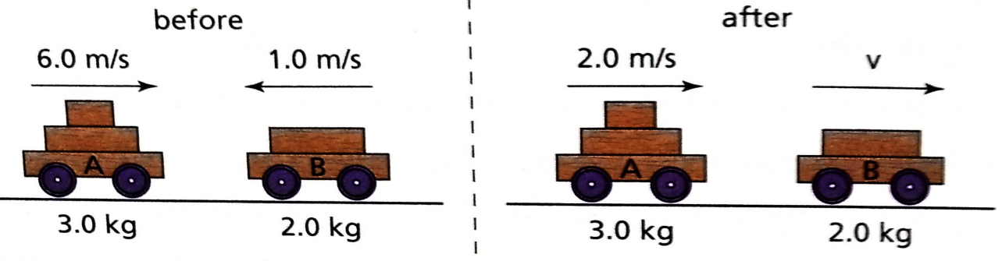

Calculate the velocity v after collision.

(3 marks)

- a) State any one difference between nuclear fusion and nuclear fission.
________________________________________________________________________________________________________________________________
(1 marks)
b) Explain why a radioactive tracer used to monitor fertilizer uptake in maize
should be of should be of short half-life.
________________________________________________________________________________________________________________________________
(2 marks)

- a) i. Define ‘kilowatt-hour’.
________________________________________________________________________________________________________________________________
(1 marks)
ii. The power rating of a television is 1500 W. How much power in Kilowatt-hours will it use if it is used for 10 hours?

(2 marks)
iii. If the cost of power is K150 per kilowatt-hour, calculate the cost of running the television in 8.a.(ii) for 10 hours per day for 2 days.

(2 marks)

b) Explain why a semiconductor becomes a poor conductor when temperature is reduced
________________________________________________________________
(1 mark)
- a) Figure 3 is a diagram showing the wiring of a three-plug used on an electric fan rated 240 V, 960 W.
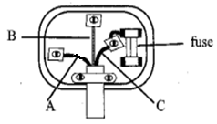Figure 3
- Name the wire labeled A. _____________________________ (1 marks)
- State the function of the wire labeled B. ___________________________________________________________
(1 mark)
- If fuses of 4A, 7A, and 13A were available, which one would be most suitable for the plug connected to the fan? ___________________________________________________________
(1 mark)
- (a) Calculate the time taken for the mass of a radioactive substance to decrease from 800 g to 50 g if its half-life is 6 hours.

(2 marks)
c) State the domain theory of magnetism. ________________________________________________________________________________________________________________________________________________________________________________________________________
(1 marks)
SECTION B (30 marks)
- a) ) you are provided with 2 match boxes; one containing two resistors connected in series the other containing two resistors connected in parallel. If the resistors used are identical, describe how you can find the match box containing two resistors connected in parallel without opening the boxes

_______________________________________________________________________________________________________________________________________________________________________________________________________________________________________________________________________________________________________________________________________________
(5 marks)
b) With an aid of a well labelled diagram describe full wave rectification by center-tapping a transformer.

__________________________________________________________________________________________________________________________________________________________________________________________________________________________________________________________________________________________________________________________________________________________________________________________________________________
(5 marks)
- a) With an aid of a well labelled diagram, describe how a photographic camera works.

________________________________________________________________________________________________________________________________________________________________________________________________________________________________________________________________________________________________________________________________________________________________________________________________________________________________________________________________
(5 marks)
b) Imagine you are provided with the following materials: soap, a stone and a nail, design an experiment that could be done to verify that pressure depends on the area of contact of a solid.

________________________________________________________________________________________________________________________________________________________________________________________________________________________________________________________________________________________________________________________________________________________________________________________________________________________________________________________________________________________________________________________________________________________________________________________________________________________________________________________________________________________________________________________________________________________________________________________________
(5 marks)
- a) Describe an experiment that you could carry out to show that different metals expand with different amounts when heated equally.

_______________________________________________________________________________________________________________________________
________________________________________________________________________________________________________________________________________________________________________________________________________________________________________________________________
(4 marks)
b) Describe how you can find the efficiency of a pulley system.

________________________________________________________________________________________________________________________________________________________________________________________________________________________________________________________________________________________________________________________________________________________________________________________________________________________________________________________________________________________________________________________________________________________________________________________________________________________________________________________________________________________________________________________________
(6 marks)

END OF QUESTION PAPER

